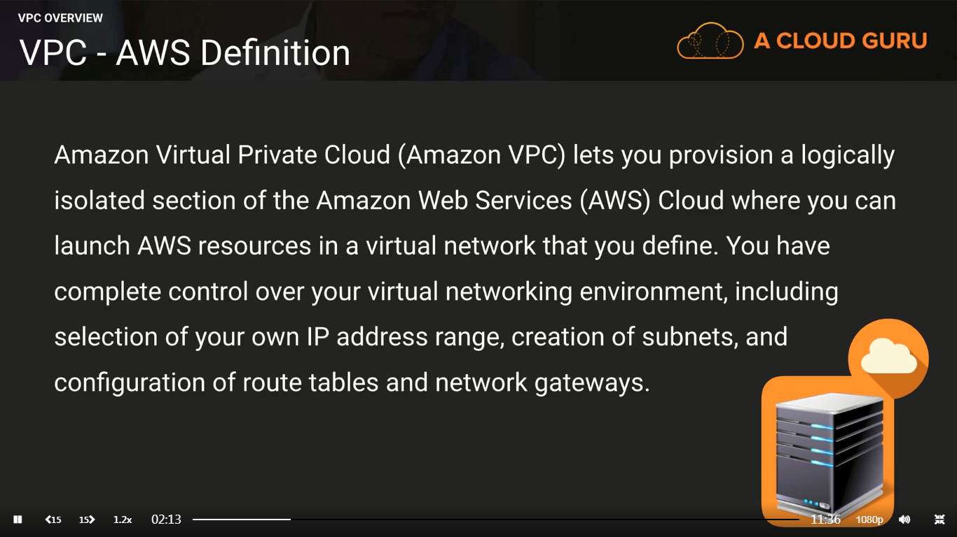

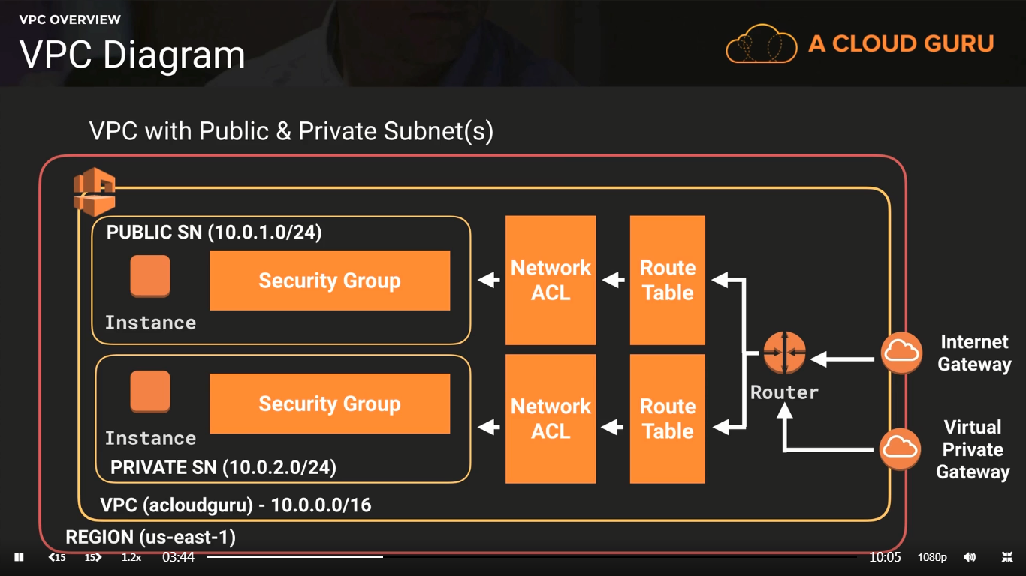

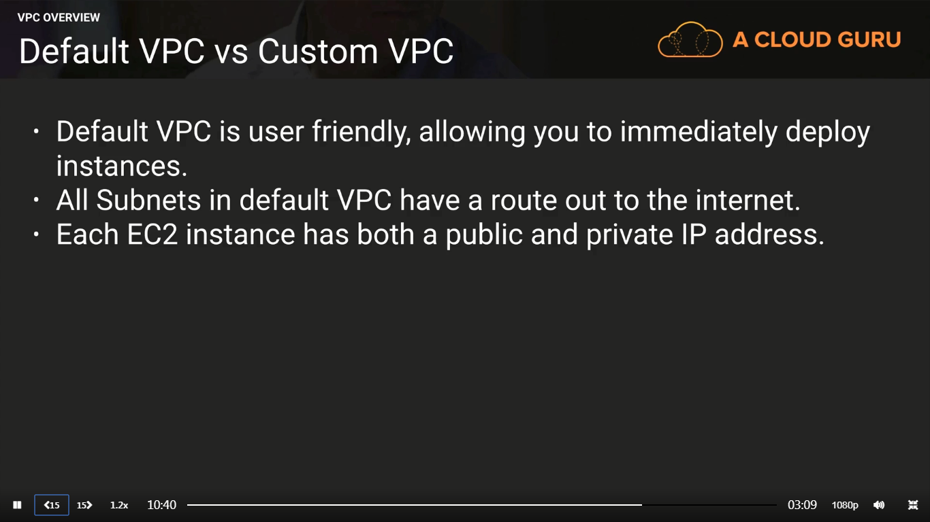

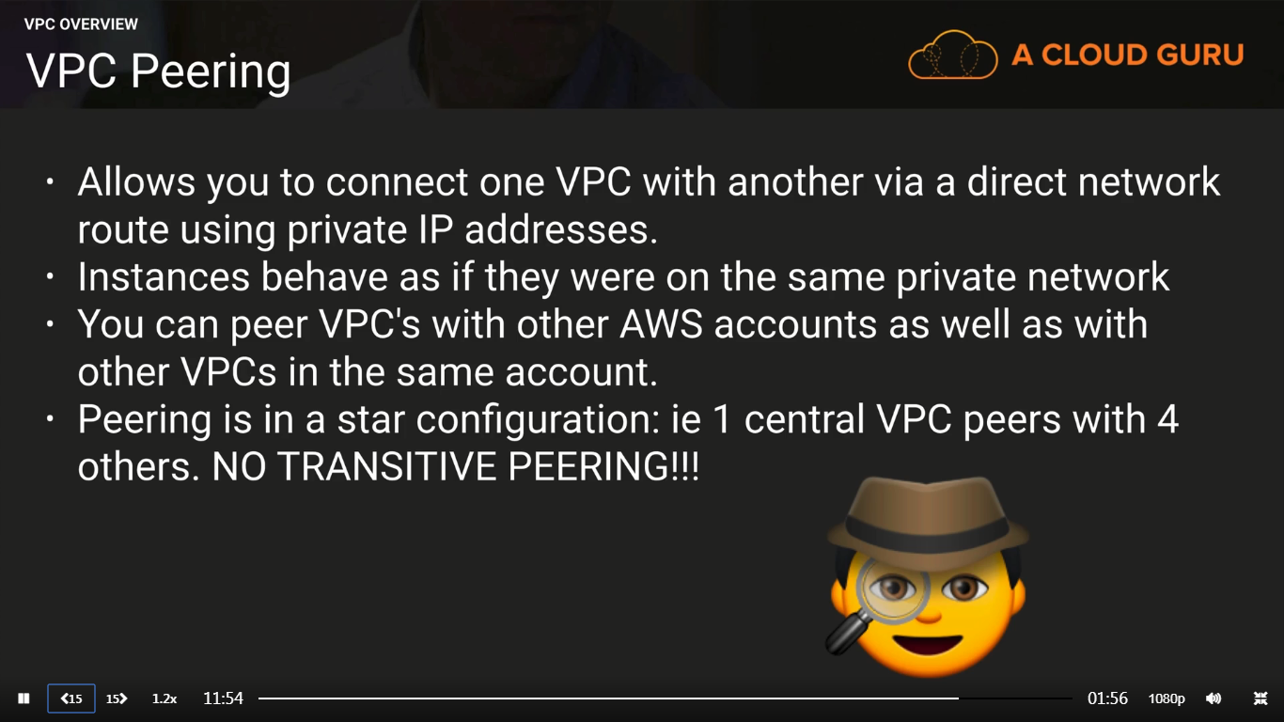

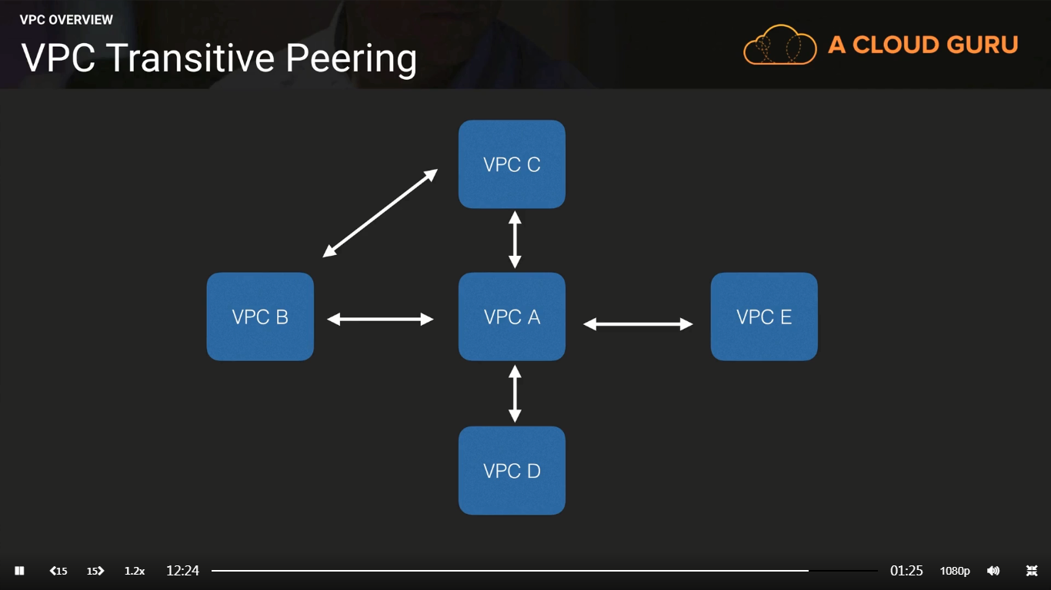

No Transitive Peering: If VPC B has to talk to VPC C, then establish a peering b/w B and C. We cannot assume “A” can handle such requests.

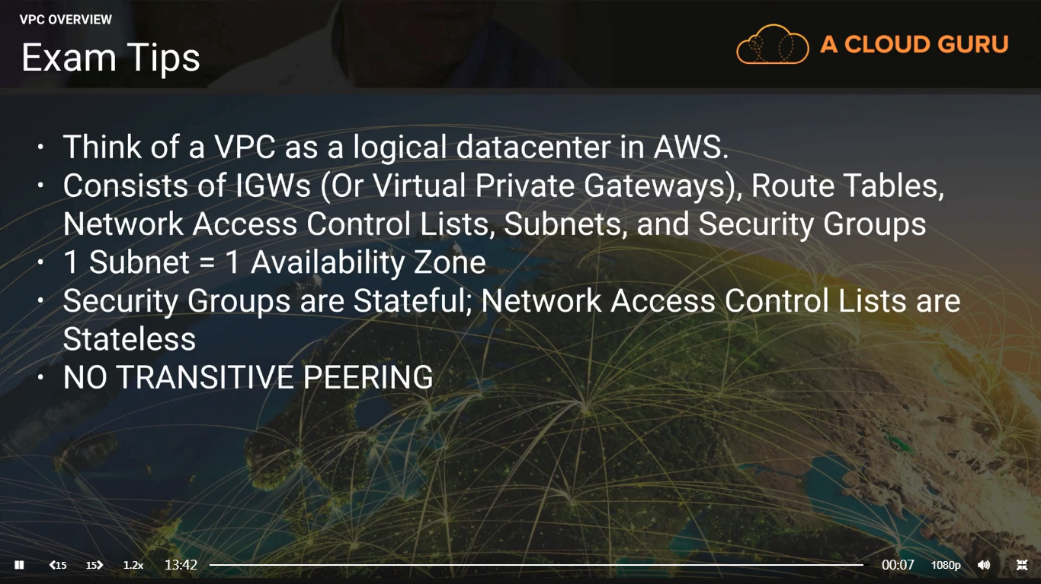

Stateful: If I specify Port 80 then both send/receive on 80 is allowed

Stateless: If I specify Port 80 then I need to specify on both Inbound and Outbound rules

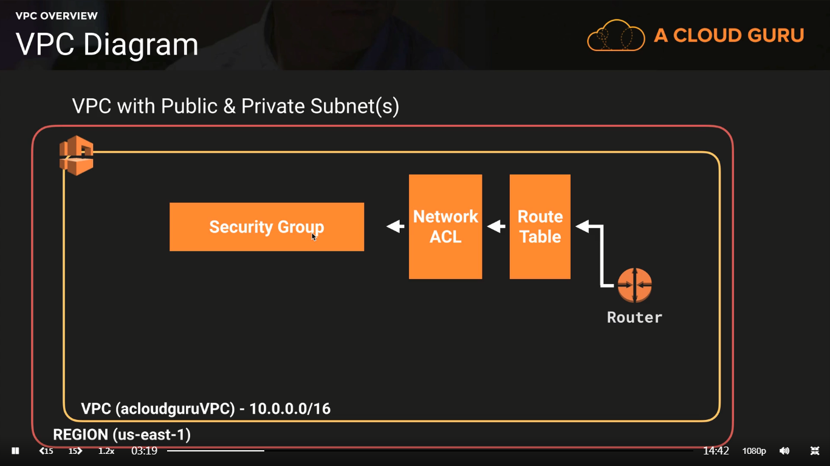

When you create a new VPC, AWS will create a default Router table, default NACL and a default SG